Sandon Public School
SANDON PUBLIC SCHOOL

Established
1993
Tel (02) 6772 3349 • Fax (02) 6772 9491
email: Sandon-p.school@det.nsw.edu.au
229 Erskine Street, Armidale NSW 2350
PO Box 92, Armidale NSW 2350
ABN 59 402 827 637

SANDON PUBLIC SCHOOL NEWSLETTER

Week 10, Term 3 – Friday 28th September 2018

SCHOOL ATTENDANCE

Last week the school had a visit from the Home School Liaison Officer and the Aboriginal School Liaison Officer. Carolyn and Sue were here to check on our attendance records. We currently have 48 students with attendance below 85%.
Encouraging regular school attendance is one of the most powerful ways you can prepare your child for success—both in school and in life. When you make school attendance a priority, you help your child get better grades, develop healthy life habits, avoid dangerous behavior and have a better chance of graduating from high school.
When students are absent for fewer days, their grades and reading skills often improve—even among those students who are struggling in school. Students who attend school regularly also feel more connected to their community, develop important social skills and friendships, and are significantly more likely to graduate from high school, setting them up for a strong future.
But when students are absent for an average of just two days of school per month—even when the absences are excused– it can have a negative impact. These absences can affect students as early as Kindergarten.
For example, young students who miss an average of just two school days per month often have difficulty keeping up with their peers academically and tend to fall behind in reading. But when students are able to read on grade level by the end of third grade, which is when kids transition from learning to read to reading to learn, they are three to four times more likely to graduate high school and attend university, post-graduate, or professional development classes than their peers who struggle with reading.
As a parent, you can prepare your child for a lifetime of success by making regular school attendance a priority.
If you child is unable to attend school please make sure you let the school know as soon as possible. You can ring, or text on the School bag app or send a note when you child returns.

Congratulations to the following students who have great attendance.
100% | 98% and above
Izaak Avagliano | Tleah Brown
Qaso Bari | Mikayla Andronicus
Layaleeta Williams – Boney | Claire Baldwin
Evelyne Bjorkander | Charlie Dare
Cyrus Avagliano | Anaru Haenga
Tyler Booth | Thomas Kitchener
Alisa Bjorkander | Madilyn McEwan
Olivia Maxwell | Marley Lomas
Sofia Bjorkander | Victoria Gerdnoi
 | Aaron Prasad
 | Kayla Sinclair
 | Brooke Hellyar
 | Jack Clayton
 | Jayarla Roberts
 | Bella Booth
 | Nikola Maxwell
 | Sealtiel Rillo
 | Annabelle Johnstone
 | Huw Davidson
 | Yino Du
 | Brodie Murray
 | Lailani Sinclair
 | Arianna Andronicos
 | Fergus Bradshaw
 | Nyla Chemane
 | Daniel Hellyar
 | Ella Kitchener
 | Samuel Rillo
 | Bradley Sawaki-Gillard
 | Tyleka Cutmor Levy
 | Sophia Andronicos
 | Alex Karsten
 | Jenna Alkaladeh
 | Isaac Hellyar
 | Philp Kaleesha
 | Eliza Cooper
 | Rachel McKay
 | Claire Chiripanyanga
 | Georgia Froome-Young
 | Noel Kiongo
 | Olivia Maxwell
 | Bryce Mendes
 | Anna Bjorkander
 | Emily Parker
 | Jade Booth
 | Mia Ball
 | Ebboni Brown
 | Waiari Haenga
 | Georgie Mendes
 | Samuel Clayton

Sandon Netball News

The Sandon Sparkles team played their grand final game on Saturday against ACSC. It was a great game and the girls played their hearts out. Unfortunately the girls didn't win, but were still super happy to come away with runners up.

Some of these girls have been playing in the Sandon team since it started 4 years ago and this was the last year before they all move into high school.
They are the kindest, most loving bunch of girls and it has been such a pleasure coaching them again this year! They always make me super proud!! Katie Roberts

5/6 Blue - Factors that Shape Places - Geography
5/6 Blue have been studying the effects of bushfires on our communities and the environment and how people help each other during these devastating times.

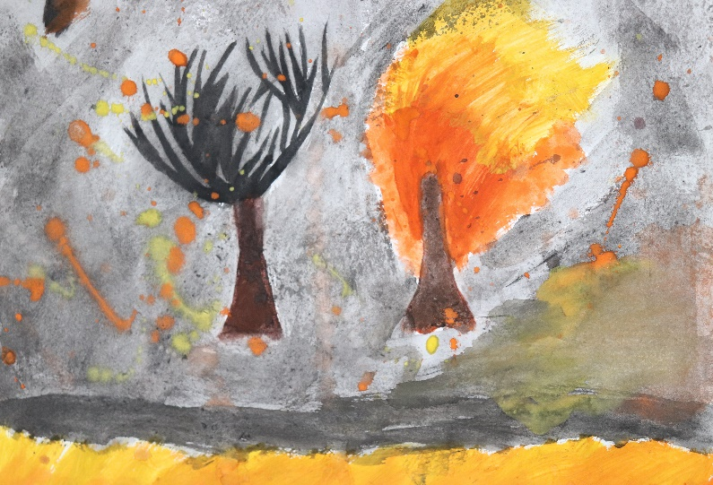
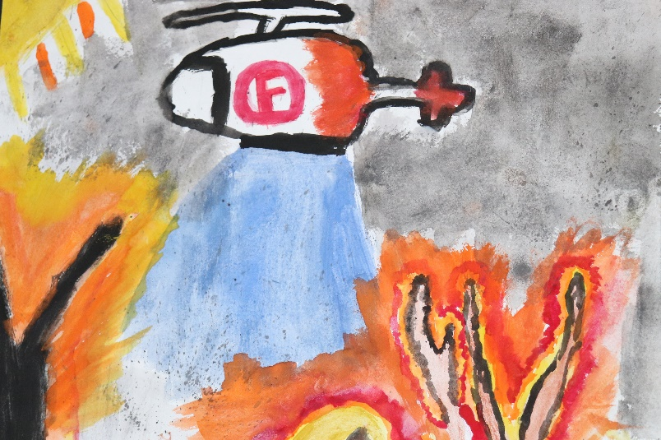
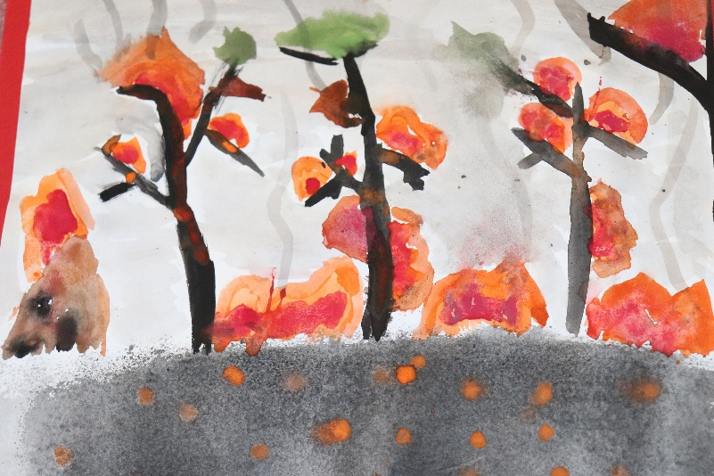

Responsible Pet Education Program

On Friday 21st September, a teacher from the Responsible Pet Education Program visited Sandon with her dog Lucy.
She educated the children how to be safe around dogs and how to say hello to dogs with their owners!
There was lots of listening, role plays, singing and dancing. The students said the best part of the program was being allowed to pat the dog.

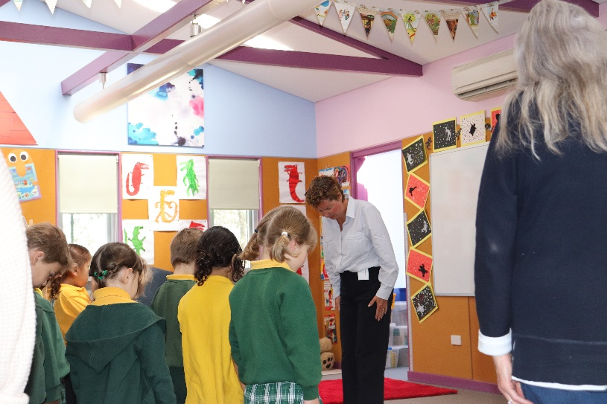
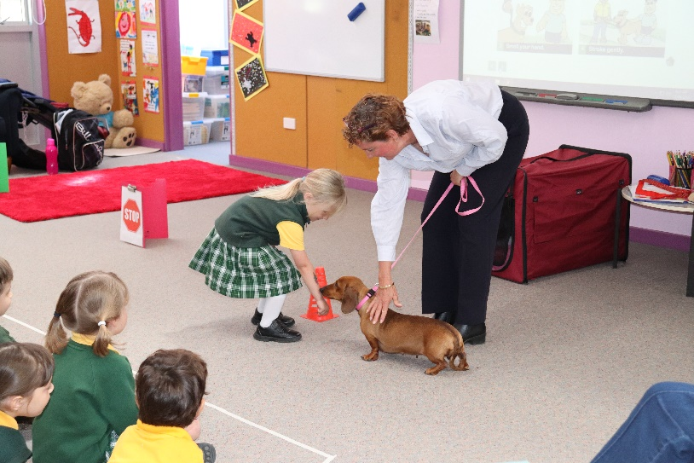

Dress as a Farmer & Disco for the Drought
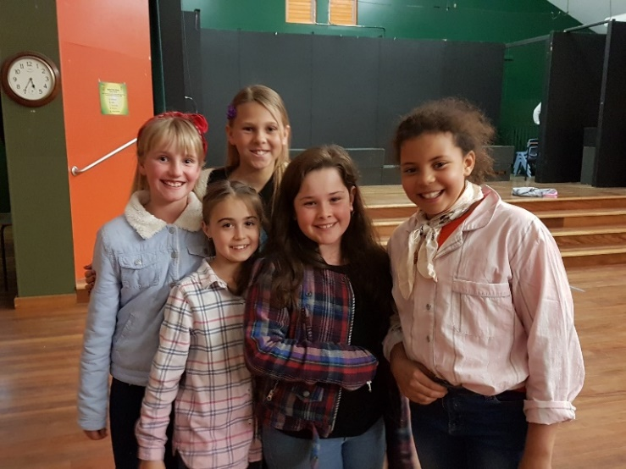
The students loved the chance to dress as a farmer for the day whilst raising money for the farmers currently affected by the drought. The students were then able to strut their moves at the K-2 and 3-6 discos. There was lots of fun had by all and they helped raise $350 for this worthy cause!

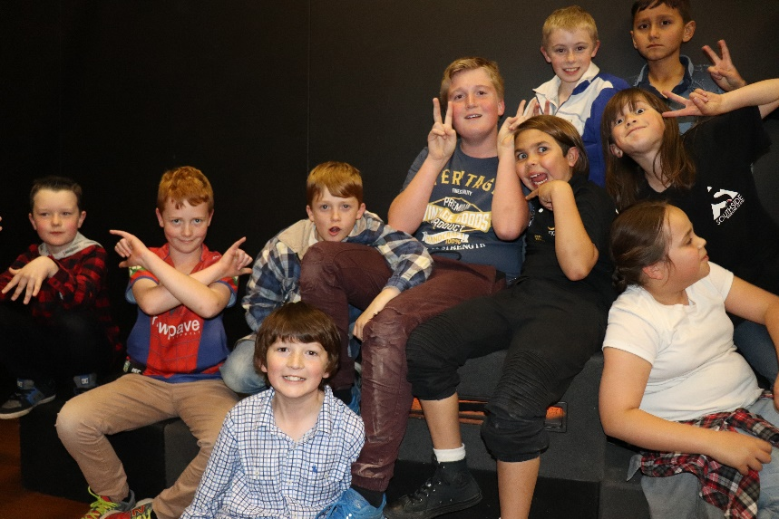

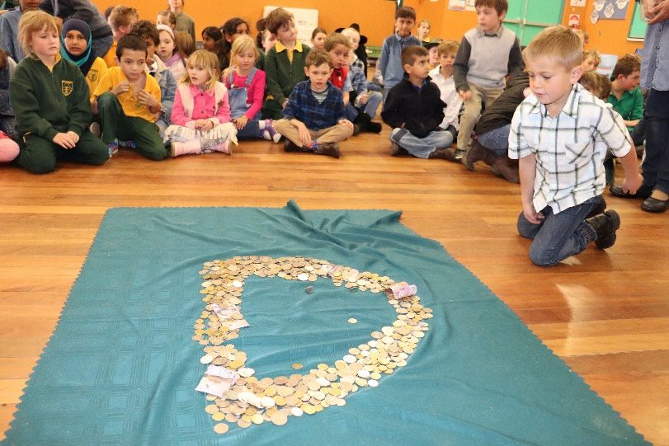

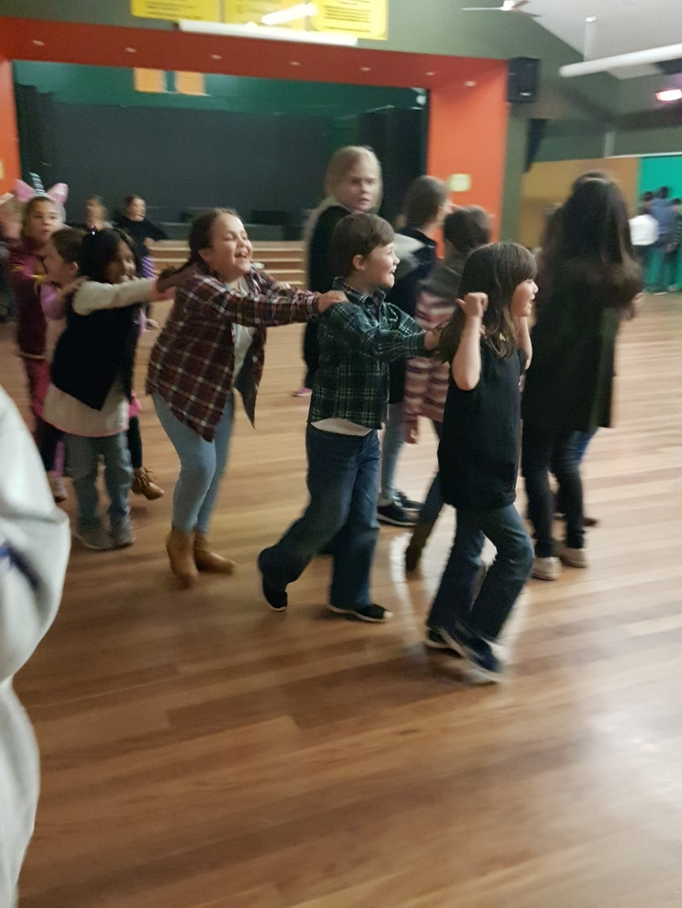
W | Sun | Mon | Tue | Wed | Thu | Fri | Sat
1 | 14/10 | 15/10  Term 4 commences. Students return to school. | 16/10 | 17/10 | 18/10  New England Sings rehearsal | 19/10 | 20/10  New England Sings-Final rehearsal  9:30-11:00
2 | 21/10  New England Sings Concert-11:00-1:00( students arrive at 10:15) | 22/10  Colour Explosion money and forms due back at school | 23/10 | 24/10 | 25/10 | 26/10  Kindergarten parent information morning  9:30-10:30  Morning tea @ 10.30 for parents. | 27/10
3 | 28/10  Sandon Colour Explosion | 29/10 | 30/10 | 31/10 | 1/11 | 2/11  Kinder Transition  9:15-11:45 | 3/11
4 | 4/11 | 5/11 | 6/11 | 7/11 | 8/11 | 9/11  Kinder Transition  9:15-11:45 | 10/11
5 | 11/11 | 12/11 | 13/11 | 14/11 | 15/11 | 16/11  Kinder Transition  9:15-11:45 | 17/11
6 | 18/11 | 19/11 | 20/11 | 21/11 | 22/11 | 23/11  Kinder Transition  9:15-11:45 | 24/11
7 | 25/11 | 26/11 | 27/11 | 28/11 | 29/11  Community Breakfast | 30/11 | 1/12
8 | 2/12 | 3/12 | 4/12 | 5/12 | 6/12 | 7/12 | 8/12
9 | 9/12 | 10/12 | 11/12 | 12/12  Performance night | 13/12 | 14/12  Presentation day and thank you morning tea | 15/12
10 | 16/12 | 17/12  Year 6 farewell dinner | 18/12 | 19/12  Students last day | 20/12 | 21/12 | 22/12
H | 23/12 | 24/12 | 25/12 | 26/12 | 27/12 | 28/12 | 29/12
H | 30/12 | 31/12 | 1/1/19 | 2/1/19 | 3/1/19 | 4/1/19 | 5/1/19
Term 4 2018

